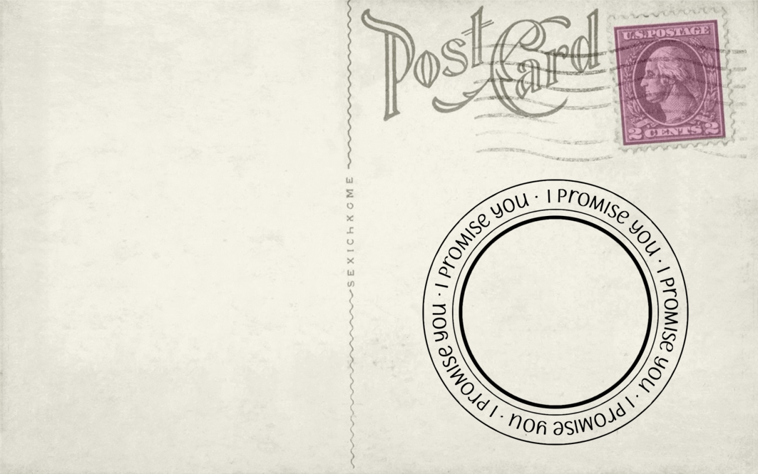

To my body,

I am sorry for the way that I have treated you in the past.

I promise to make better food choices and give you the fuel that you need to enable me to live a healthy life.

I will make sure that I work out regularly to strengthen you and get you into the good shape that you deserve to be in.

I will take sole responsibility to keep this promise to you.

All my love,

Me