NOTICE

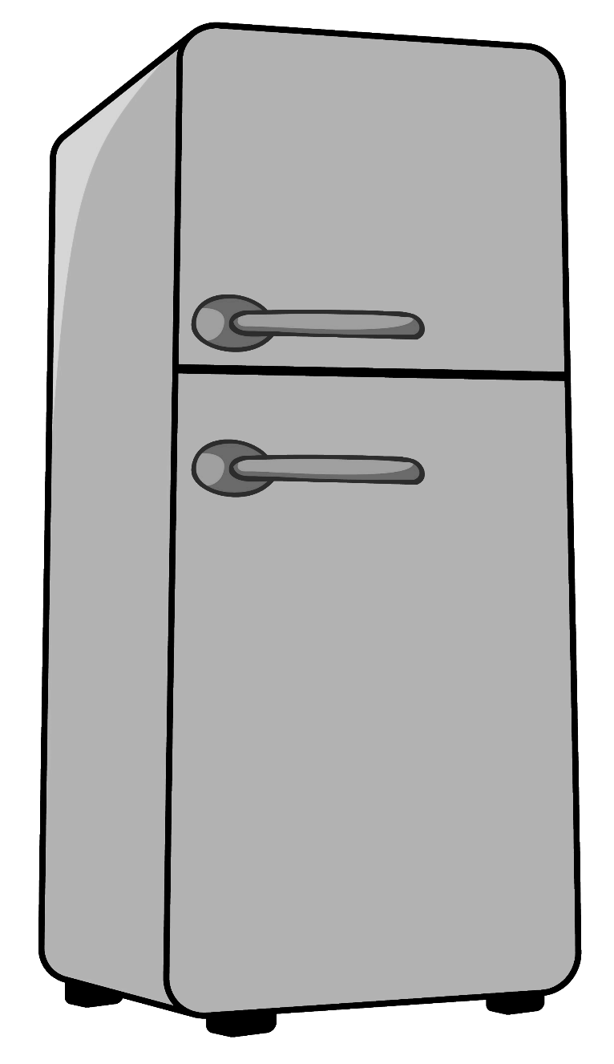

The fridge will be cleaned every Friday.

**TAKE IT OR LOSE IT!**