NOTICE

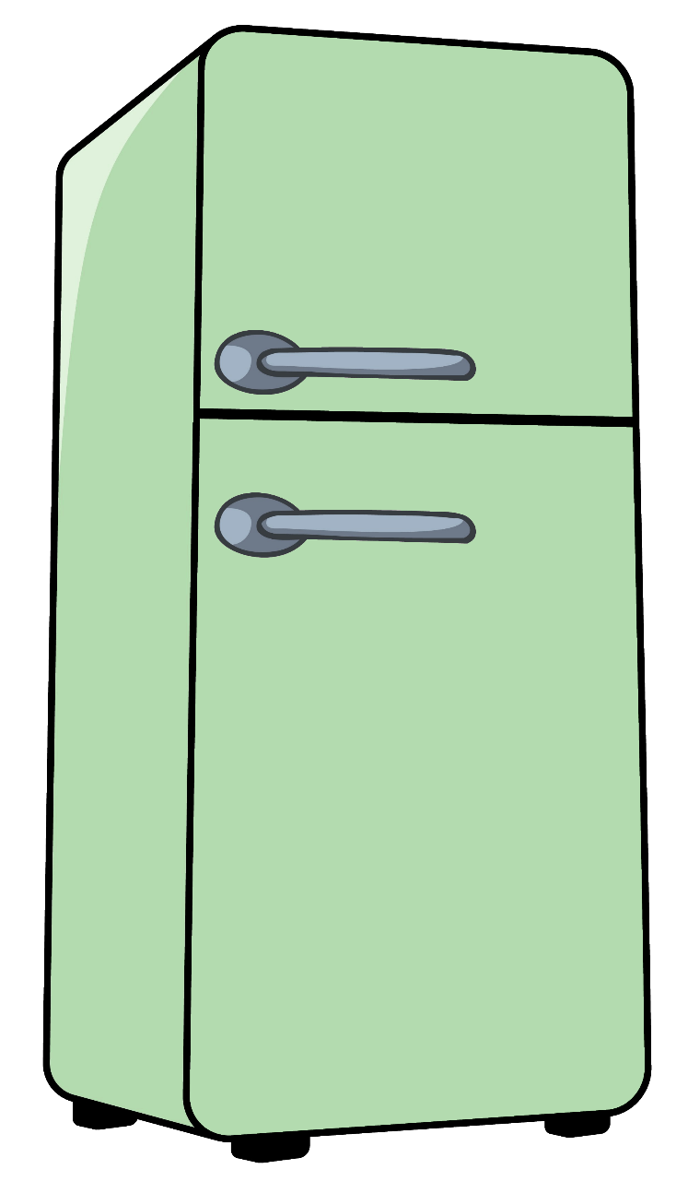

The fridge will be cleaned today.

Take it or lose it!