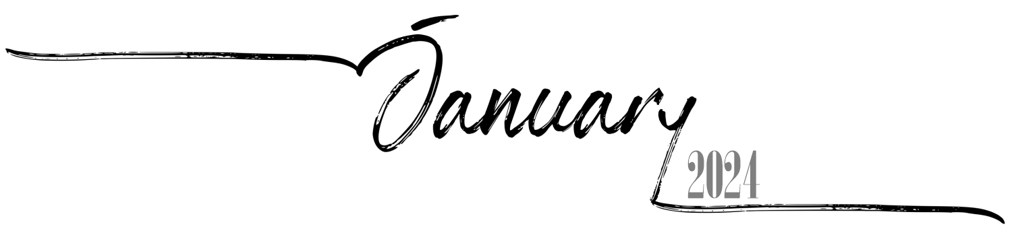

 | 1 | 2 | 3 | 4 | 5 | 6
 | 20th of Tevet, 5784 | 21st of Tevet, 5784 | 22nd of Tevet, 5784 | 23rd of Tevet, 5784 | 24th of Tevet, 5784 | 25th of Tevet, 5784
7 | 8 | 9 | 10 | 11 | 12 | 13
26th of Tevet, 5784 | 27th of Tevet, 5784 | 28th of Tevet, 5784 | 29th of Tevet, 5784 | 1st of Sh'vat, 5784 Rosh ChodeshSh'vat | 2nd of Sh'vat, 5784 | 3rd of Sh'vat, 5784
14 | 15 | 16 | 17 | 18 | 19 | 20
4th of Sh'vat, 5784 | 5th of Sh'vat, 5784 | 6th of Sh'vat, 5784 | 7th of Sh'vat, 5784 | 8th of Sh'vat, 5784 | 9th of Sh'vat, 5784 | 10th of Sh'vat, 5784
21 | 22 | 23 | 24 | 25 | 26 | 27
11th of Sh'vat, 5784 | 12th of Sh'vat, 5784 | 13th of Sh'vat, 5784 | 14th of Sh'vat, 5784 | 15th of Sh'vat, 5784 Tu BiShvat | 16th of Sh'vat, 5784 | 17th of Sh'vat, 5784
28 | 29 | 30 | 31
18th of Sh'vat, 5784 | 19th of Sh'vat, 5784 | 20th of Sh'vat, 5784 | 21st of Sh'vat, 5784

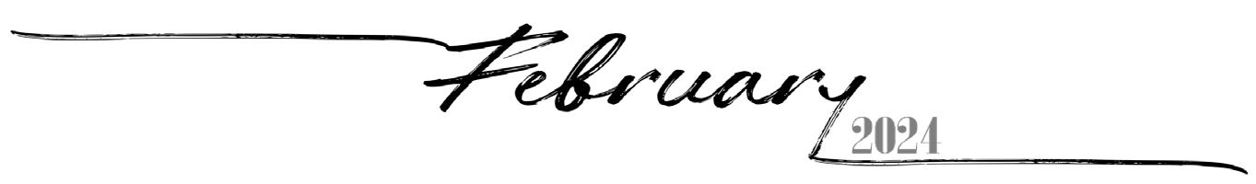
 |  |  |  | 1 | 2 | 3
 |  |  |  | 22nd of Sh'vat, 5784 | 23rd of Sh'vat, 5784 | 24th of Sh'vat, 5784
4 | 5 | 6 | 7 | 8 | 9 | 10
25th of Sh'vat, 5784 | 26th of Sh'vat, 5784 | 27th of Sh'vat, 5784 | 28th of Sh'vat, 5784 | 29th of Sh'vat, 5784 | 30th of Sh'vat, 5784 Rosh Chodesh Adar I | 1st of Adar I, 5784 Rosh Chodesh Adar I
11 | 12 | 13 | 14 | 15 | 16 | 17
2nd of Adar I, 5784 | 3rd of Adar I, 5784 | 4th of Adar I, 5784 | 5th of Adar I, 5784 | 6th of Adar I, 5784 | 7th of Adar I, 5784 | 8th of Adar I, 5784
18 | 19 | 20 | 21 | 22 | 23 | 24
9th of Adar I, 5784 | 10th of Adar I, 5784 | 11th of Adar I, 5784 | 12th of Adar I, 5784 | 13th of Adar I, 5784 | 14th of Adar I, 5784 Purim Koton | 15th of Adar I, 5784
25 | 26 | 27 | 28 | 29
16th of Adar I, 5784 | 17th of Adar I, 5784 | 18th of Adar I, 5784 | 19th of Adar I, 5784 | 20th of Adar I, 5784

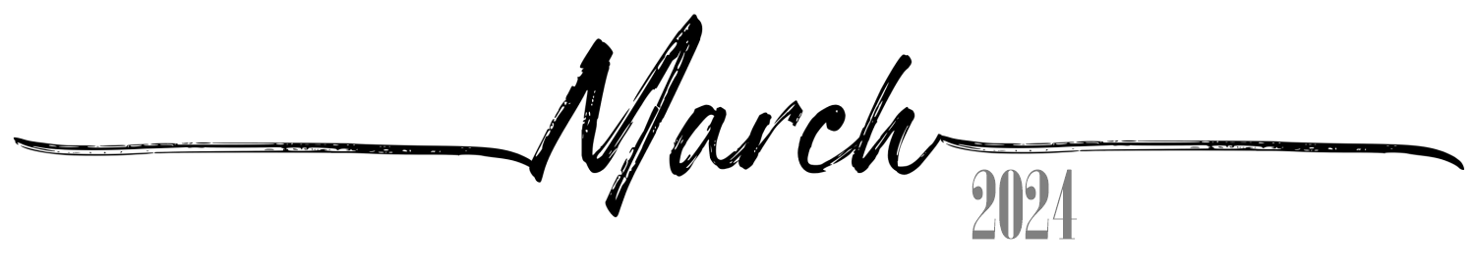
 |  |  |  |  | 1 | 2
 |  |  |  |  | 21st of Adar I, 5784 | 22nd of Adar I, 5784
3 | 4 | 5 | 6 | 7 | 8 | 9
23rd of Adar I, 5784 | 24th of Adar I, 5784 | 25th of Adar I, 5784 | 26th of Adar I, 5784 | 27th of Adar I, 5784 | 28th of Adar I, 5784 | 29th of Adar I, 5784
10 | 11 | 12 | 13 | 14 | 15 | 16
30th of Adar I, 5784 Rosh Chodesh Adar II | 1st of Adar II, 5784 Rosh Chodesh Adar II | 2nd of Adar II, 5784 | 3rd of Adar II, 5784 | 4th of Adar II, 5784 | 5th of Adar II, 5784 | 6th of Adar II, 5784
17 | 18 | 19 | 20 | 21 | 22 | 23
7th of Adar II, 5784 | 8th of Adar II, 5784 | 9th of Adar II, 5784 | 10th of Adar II, 5784 | 11th of Adar II, 5784 | 12th of Adar II, 5784 | 13th of Adar II,5784 Erev Purim
24 | 25 | 26 | 27 | 28 | 29 | 30
14th of Adar II,5784 Purim | 15th of Adar II,5784 Shushan Purim | 16th of Adar II, 5784 | 17th of Adar II, 5784 | 18th of Adar II, 5784 | 19th of Adar II, 5784 | 20th of Adar II, 5784
31
21st of Adar II, 5784

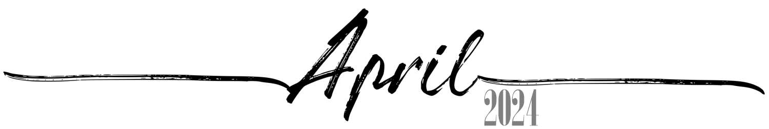
 | 1 | 2 | 3 | 4 | 5 | 6
 | 22nd of Adar II, 5784 | 23rd of Adar II, 5784 | 24th of Adar II, 5784 | 25th of Adar II, 5784 | 26th of Adar II, 5784 | 27th of Adar II, 5784
7 | 8 | 9 | 10 | 11 | 12 | 13
28th of Adar II, 5784 | 29th of Adar II, 5784 | 1st of Nisan, 5784 Rosh Chodesh Nisan | 2nd of Nisan, 5784 | 3rd of Nisan, 5784 | 4th of Nisan, 5784 | 5th of Nisan, 5784
14 | 15 | 16 | 17 | 18 | 19 | 20
6th of Nisan, 5784 | 7th of Nisan, 5784 | 8th of Nisan, 5784 | 9th of Nisan, 5784 | 10th of Nisan, 5784 Yom HaAliyah | 11th of Nisan, 5784 | 12th of Nisan, 5784
21 | 22 | 23 | 24 | 25 | 26 | 27
13th of Nisan, 5784 | 14th of Nisan, 5784 Erev Pesach | 15th of Nisan, 5784  Pesach I | 16th of Nisan, 5784  Pesach II | 17th of Nisan, 5784 Pesach III(CH''M) | 18th of Nisan, 5784 Pesach IV(CH''M) | 19th of Nisan, 5784 Pesach V(CH''M)
28 | 29 | 30
20th ofNisan, 5784 Pesach VI(CH''M) | 21st of Nisan, 5784  Pesach VII | 22nd of Nisan, 5784  Pesach VIII

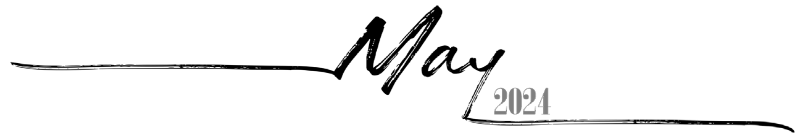
 |  |  | 1 | 2 | 3 | 4
 |  |  | 23rd of Nisan, 5784 | 24th of Nisan, 5784 | 25th of Nisan, 5784 | 26th of Nisan, 5784
5 | 6 | 7 | 8 | 9 | 10 | 11
27th of Nisan, 5784 | 28th of Nisan, 5784 Yom HaShoah | 29th of Nisan, 5784 | 30th of Nisan, 5784 Rosh ChodeshIyyar | 1st of Iyyar, 5784 Rosh ChodeshIyyar | 2nd of Iyyar, 5784 | 3rd of Iyyar, 5784
12 | 13 | 14 | 15 | 16 | 17 | 18
4th of Iyyar, 5784 | 5th of Iyyar, 5784 Yom HaZikaron | 6th of Iyyar, 5784 Yom HaAtzma'ut | 7th of Iyyar, 5784 | 8th of Iyyar, 5784 | 9th of Iyyar, 5784 | 10th of Iyyar, 5784
19 | 20 | 21 | 22 | 23 | 24 | 25
11th of Iyyar, 5784 | 12th of Iyyar, 5784 | 13th of Iyyar, 5784 | 14th of Iyyar, 5784 Pesach Sheni | 15th of Iyyar, 5784 | 16th of Iyyar, 5784 | 17th of Iyyar, 5784
26 | 27 | 28 | 29 | 30 | 31
18th of Iyyar, 5784 Lag BaOmer | 19th of Iyyar, 5784 | 20th of Iyyar, 5784 | 21st of Iyyar, 5784 | 22nd of Iyyar, 5784 | 23rd of Iyyar, 5784

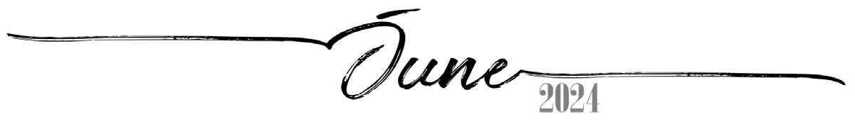
 |  |  |  |  |  | 1
 |  |  |  |  |  | 24th of Iyyar, 5784
2 | 3 | 4 | 5 | 6 | 7 | 8
25th of Iyyar, 5784 | 26th of Iyyar, 5784 | 27th of Iyyar, 5784 | 28th of Iyyar, 5784 YomYerushalayim | 29th of Iyyar, 5784 | 1st of Sivan, 5784 Rosh Chodesh Sivan | 2nd of Sivan, 5784
9 | 10 | 11 | 12 | 13 | 14 | 15
3rd of Sivan, 5784 | 4th of Sivan, 5784 | 5th of Sivan, 5784 Erev Shavuos | 6th of Sivan, 5784  Shavuos I | 7th of Sivan, 5784  Shavuos II | 8th of Sivan, 5784 | 9th of Sivan, 5784
16 | 17 | 18 | 19 | 20 | 21 | 22
10th of Sivan, 5784 | 11th of Sivan, 5784 | 12th of Sivan, 5784 | 13th of Sivan, 5784 | 14th of Sivan, 5784 | 15th of Sivan, 5784 | 16th of Sivan, 5784
23 | 24 | 25 | 26 | 27 | 28 | 29
17th of Sivan, 5784 | 18th of Sivan, 5784 | 19th of Sivan, 5784 | 20th of Sivan, 5784 | 21st of Sivan, 5784 | 22nd of Sivan, 5784 | 23rd of Sivan, 5784
30
24th of Sivan, 5784

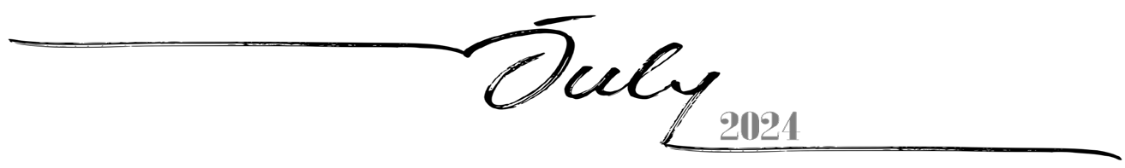
 | 1 | 2 | 3 | 4 | 5 | 6
 | 25th of Sivan, 5784 | 26th of Sivan, 5784 | 27th of Sivan, 5784 | 28th of Sivan, 5784 | 29th of Sivan, 5784 | 30th of Sivan, 5784 Rosh ChodeshTamuz
7 | 8 | 9 | 10 | 11 | 12 | 13
1st of Tamuz, 5784 Rosh ChodeshTamuz | 2nd of Tamuz, 5784 | 3rd of Tamuz, 5784 | 4th of Tamuz, 5784 | 5th of Tamuz, 5784 | 6th of Tamuz, 5784 | 7th of Tamuz, 5784
14 | 15 | 16 | 17 | 18 | 19 | 20
8th of Tamuz, 5784 | 9th of Tamuz, 5784 | 10th of Tamuz, 5784 | 11th of Tamuz, 5784 | 12th of Tamuz, 5784 | 13th of Tamuz, 5784 | 14th of Tamuz, 5784
21 | 22 | 23 | 24 | 25 | 26 | 27
15th of Tamuz, 5784 | 16th of Tamuz, 5784 | 17th of Tamuz, 5784 | 18th of Tamuz, 5784 | 19th of Tamuz, 5784 | 20th of Tamuz, 5784 | 21st of Tamuz, 5784
28 | 29 | 30 | 31
22nd of Tamuz, 5784 | 23rd of Tamuz, 5784 | 24th of Tamuz, 5784 | 25th of Tamuz, 5784

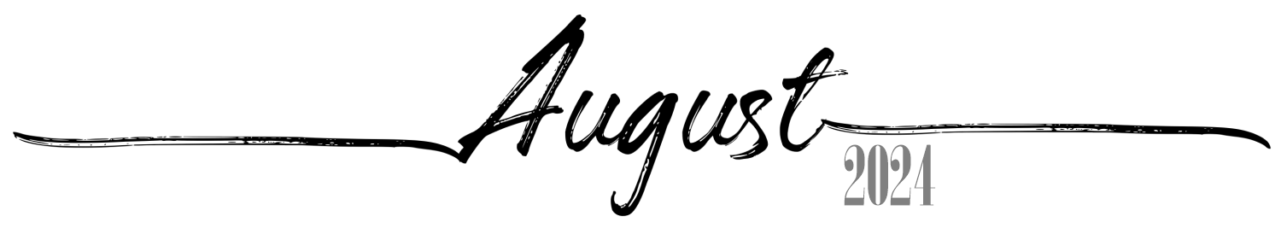
 |  |  |  | 1 | 2 | 3
 |  |  |  | 26th of Tamuz, 5784 | 27th of Tamuz, 5784 | 28th of Tamuz, 5784
4 | 5 | 6 | 7 | 8 | 9 | 10
29th of Tamuz, 5784 | 1st of Av, 5784 Rosh Chodesh Av | 2nd of Av, 5784 | 3rd of Av, 5784 | 4th of Av, 5784 | 5th of Av, 5784 | 6th of Av, 5784
11 | 12 | 13 | 14 | 15 | 16 | 17
7th of Av, 5784 | 8th of Av, 5784 Erev Tish'a B'Av | 9th of Av, 5784 Tish'a B'Av | 10th of Av, 5784 | 11th ofAv, 5784 | 12th ofAv, 5784 | 13th ofAv, 5784
18 | 19 | 20 | 21 | 22 | 23 | 24
14th ofAv, 5784 | 15th of Av, 5784 Tu B'Av | 16th of Av, 5784 | 17th of Av, 5784 | 18th ofAv, 5784 | 19th ofAv, 5784 | 20th ofAv, 5784
25 | 26 | 27 | 28 | 29 | 30 | 31
21st ofAv, 5784 | 22nd ofAv, 5784 | 23rd of Av, 5784 | 24th of Av, 5784 | 25th ofAv, 5784 | 26th ofAv, 5784 | 27th ofAv, 5784

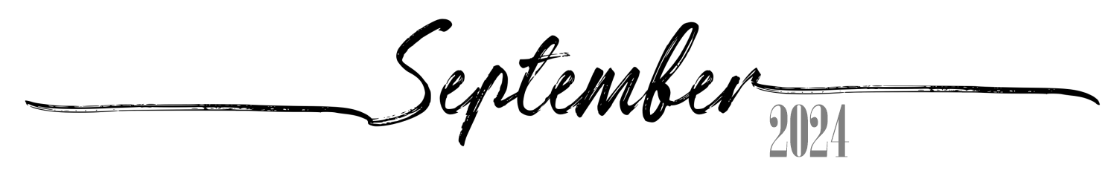
1 | 2 | 3 | 4 | 5 | 6 | 7
28th ofAv, 5784 | 29th ofAv, 5784 | 30th of Av, 5784 Rosh Chodesh Elul | 1st of Elul, 5784  Rosh HashanaLaBehemot  Rosh ChodeshElul | 2nd of Elul, 5784 | 3rd of Elul, 5784 | 4th of Elul, 5784
8 | 9 | 10 | 11 | 12 | 13 | 14
5th of Elul, 5784 | 6th of Elul, 5784 | 7th of Elul, 5784 | 8th of Elul, 5784 | 9th of Elul, 5784 | 10th of Elul, 5784 | 11th of Elul, 5784
15 | 16 | 17 | 18 | 19 | 20 | 21
12th of Elul, 5784 | 13th of Elul, 5784 | 14th of Elul, 5784 | 15th of Elul, 5784 | 16th of Elul, 5784 | 17th of Elul, 5784 | 18th of Elul, 5784
22 | 23 | 24 | 25 | 26 | 27 | 28
19th of Elul, 5784 | 20th of Elul, 5784 | 21st of Elul, 5784 | 22nd of Elul, 5784 | 23rd of Elul, 5784 | 24th of Elul, 5784 | 25th of Elul, 5784 Leil Selichos
29 | 30
26th of Elul, 5784 | 27th of Elul, 5784

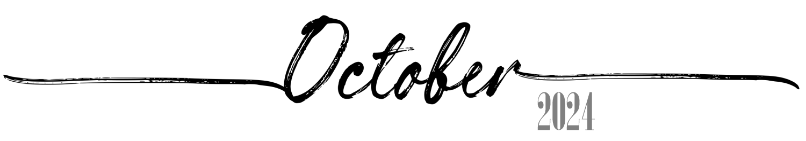
 |  | 1 | 2 | 3 | 4 | 5
 |  | 28th of Elul, 5784 | 29th of Elul, 5784 Erev RoshHashana | 1st of Tishrei, 5785  Rosh Hashana5785 | 2nd of Tishrei, 5785  Rosh Hashana II | 3rd of Tishrei, 5785
6 | 7 | 8 | 9 | 10 | 11 | 12
4th of Tishrei, 5785 | 5th of Tishrei, 5785 | 6th of Tishrei, 5785 | 7th of Tishrei, 5785 | 8th of Tishrei, 5785 | 9th of Tishrei, 5785 Erev YomKippur | 10th of Tishrei, 5785  Yom Kippur
13 | 14 | 15 | 16 | 17 | 18 | 19
11th of Tishrei, 5785 | 12th of Tishrei, 5785 | 13th of Tishrei, 5785 | 14th of Tishrei, 5785 Erev Sukkos | 15th of Tishrei, 5785  Sukkos I | 16th of Tishrei, 5785  Sukkos II | 17th of Tishrei, 5785 Sukkos III(CH''M)
20 | 21 | 22 | 23 | 24 | 25 | 26
18th of Tishrei, 5785 Sukkos IV(CH''M) | 19th of Tishrei, 5785 Sukkos V(CH''M) | 20th of Tishrei, 5785 Sukkos VI(CH''M) | 21st of Tishrei, 5785  Sukkos VII (HoshanaRaba) | 22nd of Tishrei, 5785  Shmini Atzeres | 23rd of Tishrei, 5785  Simchas Torah | 24th of Tishrei, 5785
27 | 28 | 29 | 30 | 31
25th of Tishrei, 5785 | 26th of Tishrei, 5785 | 27th of Tishrei, 5785 | 28th of Tishrei, 5785 | 29th of Tishrei, 5785

 |  |  |  |  | 1 |  | 2
 |  |  |  |  | 30th of Tishrei, 5785 Rosh ChodeshCheshvan | 1st of Cheshvan, 5785 Rosh ChodeshCheshvan
3 | 4 | 5 | 6 | 7 | 8  7th of Cheshvan, 5785  Yom HaAliyah School Observance |  | 9
2nd of Cheshvan, 5785 | 3rd of Cheshvan, 5785 | 4th of Cheshvan, 5785 | 5th of Cheshvan, 5785 | 6th of Cheshvan, 5785 |  | 8th of Cheshvan, 5785
10 | 11 | 12 | 13 | 14 | 15 |  | 1  6
9th of Cheshvan, 5785 | 10th of Cheshvan, 5785 | 11th of Cheshvan, 5785 | 12th of Cheshvan, 5785 | 13th of Cheshvan, 5785 | 14th of Cheshvan, 5785 | 15th of Cheshvan, 5785
17 | 18 | 19 | 20 | 21 | 22 |  | 2  3
16th of Cheshvan, 5785 | 17th of Cheshvan, 5785 | 18th of Cheshvan, 5785 | 19th of Cheshvan, 5785 | 20th of Cheshvan, 5785 | 21st of Cheshvan, 5785 | 22nd of Cheshvan, 5785
24 | 25 | 26 | 27 | 28 | 29 |  | 3  0
23rd of Cheshvan, 5785 | 24th of Cheshvan, 5785 | 25th of Cheshvan, 5785 | 26th of Cheshvan, 5785 | 27th of Cheshvan, 5785 | 28th of Cheshvan, 5785 | 29th of Cheshvan, 5785  Sigd
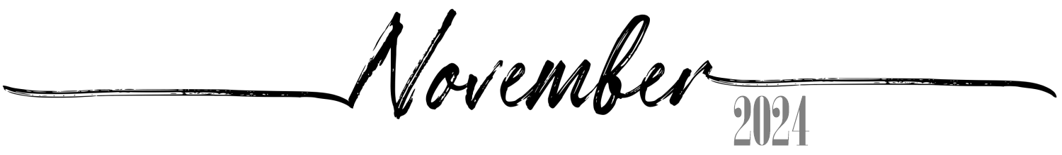

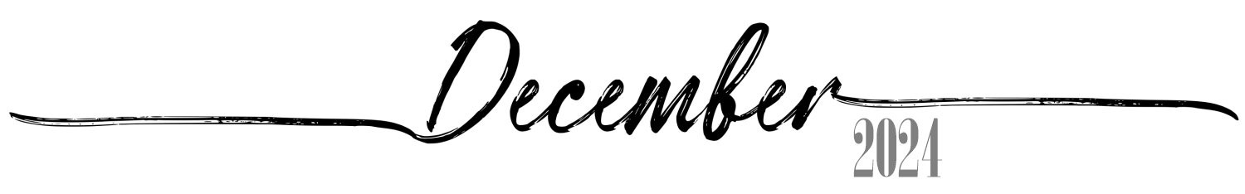
1 | 2 | 3 | 4 | 5 | 6 | 7
30th of Cheshvan, 5785 Rosh ChodeshKislev | 1st of Kislev, 5785 Rosh ChodeshKislev | 2nd of Kislev, 5785 | 3rd of Kislev, 5785 | 4th of Kislev, 5785 | 5th of Kislev, 5785 | 6th of Kislev, 5785
8 | 9 | 10 | 11 | 12 | 13 | 14
7th of Kislev, 5785 | 8th of Kislev, 5785 | 9th of Kislev, 5785 | 10th of Kislev, 5785 | 11th of Kislev, 5785 | 12th of Kislev, 5785 | 13th of Kislev, 5785
15 | 16 | 17 | 18 | 19 | 20 | 21
14th of Kislev, 5785 | 15th of Kislev, 5785 | 16th of Kislev, 5785 | 17th of Kislev, 5785 | 18th of Kislev, 5785 | 19th of Kislev, 5785 | 20th of Kislev, 5785
22 | 23 | 24 | 25 | 26 | 27 | 28
21st of Kislev, 5785 | 22nd of Kislev, 5785 | 23rd of Kislev, 5785 | 24th of Kislev, 5785 Chanukah: 1Candle | 25th of Kislev, 5785 Chanukah: 2Candles | 26th of Kislev, 5785 Chanukah: 3Candles | 27th of Kislev, 5785 Chanukah: 4Candles
29 | 30 | 31
28th of Kislev, 5785 Chanukah: 5Candles | 29th of Kislev, 5785 Chanukah: 6Candles | 30th of Kislev, 5785 Chanukah: 7Candles Rosh ChodeshTevet

